Gordon v. Southern United Fire Ins. Co.
La.App. 4 Cir.,1996.

Court of Appeal of Louisiana,Fourth Circuit.
Earline GORDON
v.
SOUTHERN UNITED FIRE INSURANCE COMPANY.
No. 95-C-2388.

Aug. 21, 1996.

Widow injured in automobile accident sued her late husband's automobile insurer, seeking uninsured motorist (UM) coverage. The First City Court of New Orleans, No. 95-52129,Niles A. Hellmers, J., denied insurer's summary judgment motion. Insurer sought writ of certiorari. After first rehearing, 674 So.2d 431, the Court of Appeal, Byrnes, J., granted second rehearing on its own motion, and, sitting en banc, held that UM coverage rejection form that husband had signed did not have to offer limits lower than were statutorily available or explain absence of lower limits in order to be valid.

Judgment on first rehearing vacated; original judgment reinstated; writ granted; judgment of trial court reversed.

Waltzer, J., dissented and assigned reasons, joined by Jones, J.

Murray, J., dissented and assigned reasons, joined by Plotkin, J.

Armstrong, J., dissented.

West Headnotes

[1] Insurance 217 2778

217 Insurance
217XXII Coverage--Automobile Insurance
217XXII(D) Uninsured or Underinsured Motorist Coverage
217k2773 Mandatory Coverage
217k2778 k. Acceptance or Rejection. Most Cited Cases
(Formerly 217k130.5(4))
Uninsured motorist (UM) coverage rejection form that offered two choices-acceptance of UM coverage equal to bodily injury liability limits or total rejection of UM coverage-was valid, insofar as policy provided bodily injury liability coverage of $10,000 per person and $20,000 per accident, since UM statute does not permit UM limits to be less than those amounts. LSA-R.S. 22:1406, subd. D(1)(a).

[2] Insurance 217 2778

217 Insurance
217XXII Coverage--Automobile Insurance
217XXII(D) Uninsured or Underinsured Motorist Coverage
217k2773 Mandatory Coverage
217k2778 k. Acceptance or Rejection. Most Cited Cases
(Formerly 217k130.5(4))
Statute governing uninsured motorist (UM) coverage requires only that rejection of UM coverage be in writing, not that acceptance of UM coverage be in writing; it is “R.S.V.P. regrets only” statute. LSA-R.S. 22:1406, subd. D(1)(a).

*583Scott D. Beal, Morris Bart, P.L.C., New Orleans, for Plaintiff/Respondent.
Peirce A. Hammond II, New Orleans, for Defendant/Relator.

Before M. SCHOTT, C.J., and BARRY, KLEES, BYRNES, CIACCIO, LOBRANO, ARMSTRONG, PLOTKIN, JONES, WALTZER, LANDRIEU and MURRAY, JJ.

BYRNES, Judge.
On its own motion, this Court grants a second rehearing en banc in order to reconsider the decision rendered on the first rehearing. We now vacate the judgment rendered on the first rehearing, and reinstate the original judgment of this Court in which we granted the defendant's writ application and reversed the trial court's denial of defendant/relator, Southern United Fire Insurance Company's motion for summary judgment.

Plaintiff, Earline Gordon filed suit against the defendant, Southern United Fire Insurance Company (Southern), her late husband's UM insurer, seeking payment under for injuries she received in an automobile accident. Southern filed a motion for summary judgment on the grounds that UM coverage had been rejected. The Southern policy provided for liability coverage in the amount of $10,000 per person and $20,000 per accident. The application form contained the following section which was separately signed by the decedent:

UNINSURED MOTORISTS PROTECTION-COVERAGE SELECTION

Louisiana law requires that all automobile policies issued or delivered in this state shall afford Uninsured Motorist [sic] Coverage unless the insured shall reject such coverage.

I HAVE BEEN OFFERED and I hereby REJECT Uninsured Motorists Bodily Injury coverage.

SIGNATURE OF APPLICANT ________________________________

Date Time

The trial court denied the motion for summary judgment. We find no genuine issues of material fact and reverse.

[1] As a matter of law, Mr. Gordon clearly and unambiguously rejected UM coverage and the UM rejection form was valid.

When bodily injury coverage is 10/20 and, therefore, there is no UM coverage available below those limits, the insurer is not required to explain the absence of lower limits or to offer a limit that was legally unavailable. In *584Morgan v. Sanchez, 635 So.2d 786 (La.App. 1st Cir.1994), the insured purchased a 10/20 policy; and the form that she signed gave her the option of selecting 10/20 UM coverage or of rejecting UM coverage entirely. In finding a valid rejection of UM coverage, the court stated:

Initially, we note that pursuant to La.R.S. 22:1406(D)(1)(a)(i) and La.R.S. 32:900(B)(2), the limits of a UM policy may not be less than 10/20. Accordingly, when the insured's bodily injury coverage is 10/20 and, therefore, there is no UM coverage legally available to the insured for limits lower than 10/20, there is no requirement that the insurer either explain the absence of a lower limit or make some meaningless offer of the non-existent lower limit. Id. at 787.

The same result was reached in Thomas v. Goodson, 26,356 (La.App. 2 Cir. 12/7/94), 647 So.2d 1192, and West v. Louisiana Indem. Co., 26,845 (La.App.2d Cir. 4/5/95), 653 So.2d 194.

The Southern form in the instant case adequately offered the two choices available, acceptance of UM coverage equal to the bodily injury liability limits or total rejection of UM coverage, because if the UM coverage was not affirmatively rejected, then it was necessarily accepted. The insured did not have to perform an affirmative act to accept UM coverage because such coverage is automatically written into the policy by operation of law unless it is rejected or lower limits are selected, and the insured is so informed.

Banks v. Patterson Insurance Company, 94-1176 (La.App. 1 Cir. 9/14/95), 664 So.2d 127,writ denied,95-2951 (La. 2/16/96), 667 So.2d 1052), is not persuasive. In Banks, 664 So.2d at 129, the First Circuit was motivated by a finding that “Louisiana Indemnity's UM rejection form foreclosed informing Ms. Sullivan of an option given by law” based on the following policy language:

UNINSURED MOTORISTS COVERAGE REJECTION POLICY HOLDER'S REJECTION OF INSURANCE PROTECTION AGAINST UNINSURED MOTORISTS

The undersigned insured hereby rejects Protection Against Uninsured Motorists as provided in Louisiana Revised Statutes 22:1406 from Policy Number 610054270 on Emma Sullivan and subsequent renewals issued by Louisiana Indemnity Co.

This quoted language from Banks is very different from the language found in Southern's policy that explicitly informs the insured of the fact that UM coverage will be provided as required by law unless rejected. The form in Banks allows the insured to reject UM coverage, but fails to inform the insured that such coverage must be furnished by the insured in the absence of rejection.

[2]LSA-R.S. 22:1406(D)(1)(a) requires that a rejection of UM coverage be in writing. LSA-R.S. 22:1406(D)(1)(a) does not require that an acceptance of UM coverage be in writing. If any inference is to be drawn from the statute's insistence on written rejection of UM coverage while failing to symmetrically mandate that rejection be also in written form, it is that acceptance of UM may be tacit, not written. You might say that LSA-R.S. 22:1406(D)(1)(a) is an “R.S.V.P. regrets only” statute. There is no need to do the vain and useless task of executing a written election for what is given by law. The only matter of legal consequence is the making of an informed decision. Any reasonable manner of execution of that informed decision should be acceptable as the statute mandates no form other than the rejection of UM coverage be in writing. Had it been the intention of the legislature to require that the acceptance of such coverage be in writing, it would have specifically so stated at the same time it specifically required that the rejection of UM coverage be in writing. The intent of LSA-R.S. 22:1406(D)(1)(a) was to protect the insured from unwittingly being without UM coverage.

Holbrook v. Holliday, 93-1639 (La.App. 3 Cir. 6/1/94); 640 So.2d 804, 807, clearly shows both that informed election is the issue and that if the election is for UM coverage the policy holder need do nothing:

Because the statute automatically provides for UM coverage equal to the bodily injury limits, absent a rejection of UM coverage or selection of lower limits in writing, the customer possesses UM coverage as a *585 matter of law. In other words, the policyholder does not have to do an affirmative act; that is, indicate in any manner their choice for UM coverage equal to the bodily injury liability limits of the policy. If the Holbrooks had done nothing on the form, UM coverage would have been automatically provided. Thus, although Tugwell and the statute provide for three options, only two of those options, [emphasis added] the rejection of UM coverage and the selection of UM coverage with limits lower than the policy's bodily injury liability limits, require an affirmative act on the part of the policyholder. [Emphasis added.]

We find that State Farm's Acknowledgement of UM Coverage Selection or Rejection form does not comply with the statutory and jurisprudential requirements allowing an insured to make an informed [emphasis original] decision as to the rejection of UM coverage where it does not list each option as Tugwell mandates.

Similarly, the issue in McCoy v. State Farm Mutual Automobile Insurance Company, 95-689 (La.App. 3 Cir. 11/2/95), 664 So.2d 572, 575, was whether the form “allowed an insured to make an informed decision.”

Herman v. Rome, 95-666, 95-831 (La.App. 5 Cir. 1/17/96); 668 So.2d 1202 is not persuasive. In Herman the court noted that “the form does not state the failure of the applicant to reject UM coverage ... would result in UM coverage being provided ...” Id. at 1206. In the instant case the Southern form does so state.

Fontenot v. Henderson, 95-2784 p. 2 (La.App. 4 Cir. 2/15/96); 670 So.2d 489, 490, is inapposite. Unlike the form in the instant case, the policy form in Fontenot did not state that UM coverage is furnished “unless the insured shall reject such coverage.” Therefore, as distinguished from the Southern form in the instant case, the Fontenot form did not explain that UM coverage would be provided as required by law unless rejected.

To provide plaintiff with coverage that was rejected under the facts of this case is to provide a windfall for which no premiums were paid at the expense of the motoring public whose premiums must cover this cost. This is bad public policy. Plaintiff's reasoning is implicitly based upon a false analogy to those cases where the insurance company collects premiums and then attempts to renege on coverage based on obscure fine print or some casuistic interpretation of arcane policy language. Southern would certainly have been only too glad to collect more premium dollars by selling plaintiff the UM coverage. That is the nature of their business. Plaintiff, in effect, asks this Court to find that Southern would act contrary to its own economic best interest, rather than provide UM coverage to policyholders.

For the foregoing reasons, we reverse the judgment of the trial court and grant summary judgment in favor of the defendant/relator, Southern United Fire Insurance Company, and against the plaintiff/respondent, Earline Gordon, dismissing plaintiff's action.

SECOND REHEARING GRANTED; JUDGMENT ON FIRST REHEARING VACATED; ORIGINAL JUDGMENT REINSTATED, GRANTING THE WRIT AND REVERSING THE TRIAL COURT.

ARMSTRONG, J., dissents.
PLOTKIN, J., dissents for the reasons assigned by MURRAY, J.
JONES, J., dissents for the reasons assigned by WALTZER, J.
WALTZER and MURRAY, JJ., dissent with written reasons.
WALTZER, Judge, dissenting with written reasons.
Because the majority opinion does not contain a discussion of the standards for summary judgment, I have included the standards which will be applied in this dissent, so that the reader can initially focus on the scope of review presently before us.

In reviewing summary judgment cases, appellate courts review summary judgments de novo, using the same criteria applied by trial courts to determine whether summary judgment*586 is appropriate. Schroeder v. Board of Sup'rs of Louisiana State University, 591 So.2d 342, 345 (La.1991); Reynolds v. Select Properties, Ltd., 93-C-1480 (4/11/94), 634 So.2d 1180, 1182.

A summary judgment shall be granted if the pleadings, depositions, answers to interrogatories, and admissions on file, together with the affidavits, if any, show that there is no genuine issue of material fact, and that the mover is entitled to judgment as a matter of law.La.C.C.P. art. 966(B).

To satisfy his burden, the party moving for the summary judgment must meet a strict standard by showing that it is quite clear as to what the truth is, and that excludes any real doubt as to the existence of material fact. Dibos v. Bill Watson Ford, Inc., 622 So.2d 677, 680 (La.App. 4 Cir.1993); Vermilion Corp. v. Vaughn, 397 So.2d 490 (La.1981).

All evidence and inferences drawn from the evidence must be construed in the light most favorable to the party opposing the motion.Carr v. City of New Orleans, 622 So.2d 819, 822 (La.App. 4 Cir.1993), writ denied629 So.2d 404 (La.1993). The papers supporting the position for the party moving for the summary judgment are to be closely scrutinized while the opposing papers are to be indulgently treated, in determining whether mover has satisfied his burden. Vermilion, supra. Where the trial court is presented with a choice of reasonable inferences to be drawn from subsidiary facts contained in affidavits and attached exhibits, reasonable inferences must be viewed in the light most favorable to the party opposing the motion.Duvalle v. Lake Kenilworth, Inc. 396 So.2d 1268 (La.1981).

A motion for summary judgment is not appropriate for disposition of cases requiring a judicial determination of subjective facts, e.g., motive, intent, good faith, knowledge.Jefferson Parish School Bd. v. Rowley Co., Inc., 305 So.2d 658, 663 (La.App. 4 Cir.1974); Butler v. Travelers Ins. Co., 233 So.2d 271 (La.App. 1 Cir.1970).

Upon my independent review of the writ application before us, I believe that there are four possible reasons why the trial court judge ruled against the motion for summary judgment: (1) the UM waiver form signed by Mr. Gordon is physically defective upon its face; (2) the UM waiver form fails to provide for a “meaningful rejection”; (3) the mover failed to carry its summary judgment burden of proof in that the affidavit of Karol Brown is insufficient; (4) Southern's market strategy is violative of Louisiana law.

I. FORM FACIALLY DEFECTIVE

A. PHYSICAL CHARACTERISTICS OF THE FORM

The top half of the application form in the instant case indicates that Elijah Gordon was a 64 year old laborer. Mr. Gordon paid a $650.00 premium plus a $45 “policy fee” and $5 “MVR” for 6 months 10/20/10 coverage on two 14 year old cars. Approximately $601.00 of the $700.00 was financed, although we do not know the interest rate, length of payment or other terms of financing because none of the finance documents are included in the writ application.

A copy of the application and a copy of the declarations page are attached hereto and made a part hereof as if copied in total:

*587

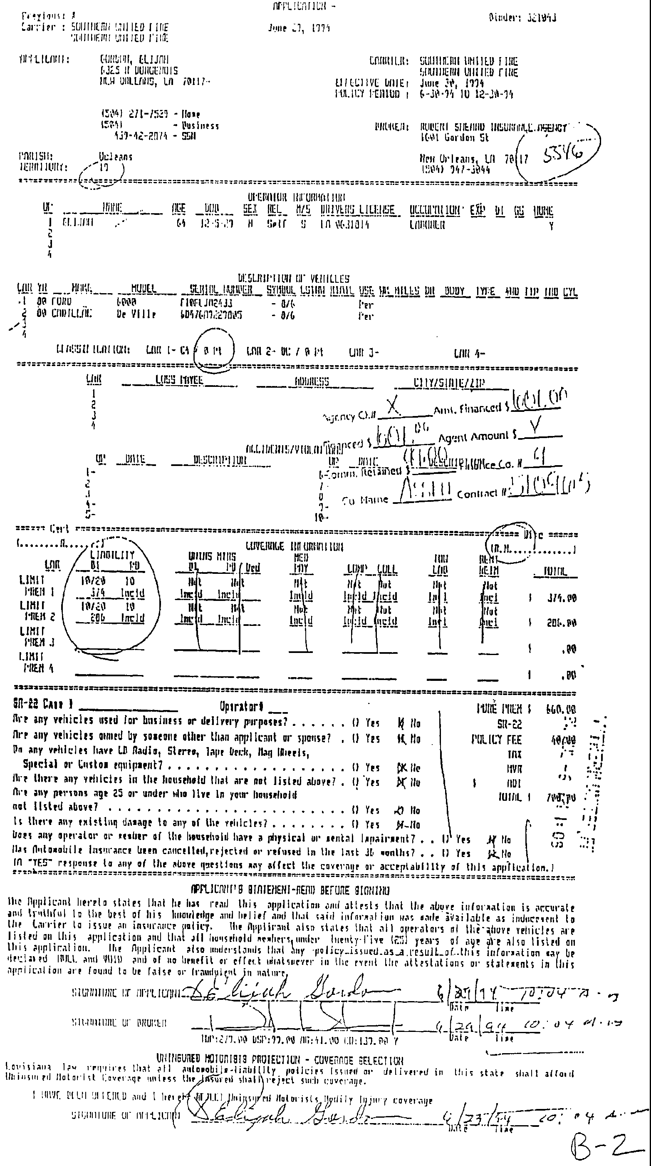

*588

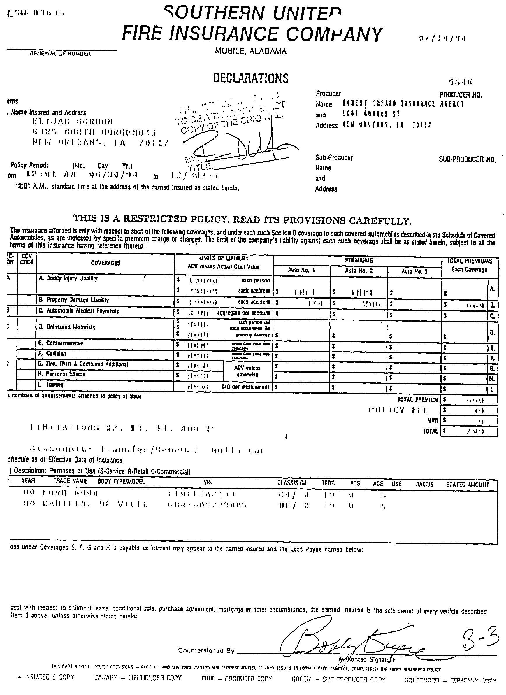

-----

The reader's attention is directed to the bottom of the application form, where in minute, crinkled and barely legible type the language appears:

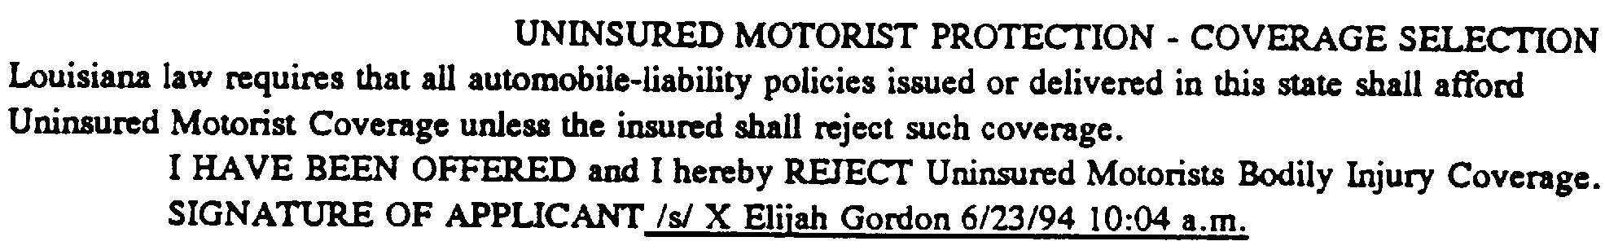

-----

*589 In Holbrook v. Holliday, 93-1639 (La.App. 3 Cir.1994), 640 So.2d 804, 808, the court noted that the heading of the form at issue therein was “ ‘Louisiana Uninsured Motor Vehicle Coverage’ when the form was used, not to obtain UM coverage, but only to select lower limits or reject UM coverage.” ^{FN1} (Emphasis supplied). Likewise, the form in the instant case is entitled “UNINSURED MOTORIST PROTECTION-COVERAGE SELECTION” when the form does not select coverage, but rather only rejects it. The correct label for the form in the instant case is “UNINSURED MOTORIST PROTECTION-COVERAGE REJECTION”. Elderly eyes, minute print and a misleading title is a combination fraught with possibilities for misleading the consumer.

FN1. Quoting the period contained in the original opinion.

The Holbrook court also noted at page 808 that the print size used in the rejection form in that case is “ordinary-sized print”, apparently believing that a UM rejection should be in larger print. In contrast, the print in the instant case is crinkled and minute. This court has had trouble reading the print in the Gordon rejection form. How well could Mr. Gordon, a 64 year old laborer see the print?

The application form at approximately the bottom third of the page has two areas for signature. The first area is entitled “APPLICANT'S STATEMENT-READ BEFORE SIGNING” and the second area, which does not mention a word about reading before signing, is the rejection form entitled “UNINSURED MOTORIST PROTECTION-COVERAGE SELECTION”. On both of Elijah Gordon's signature lines there are handwritten “x”s before his signature. Did the Sheard agent say “Sign here and here”, as he marked the “x”s on the lines? We do not know. Although Elijah Gordon has experienced the ultimate silence and will never be able to tell us what happened, what about the Sheard agent?

I further note that the form indicates not only that Elijah Gordon's signature on the UM Coverage Selection line is dated “6/23 /94 10:04 a.m.”, but also that both Elijah Gordon's signature and the signature of the agent of the Robert Sheard Insurance Agency who signed the application ^{FN2} are dated “6/29 /94 10:04 a.m.” Obviously, there is a discrepancy and at least two possible interpretations come readily to mind.

FN2. The signature is illegible.

The first interpretation is that the “3” in “6/23/94 10:04 a.m.” is a mistake and that line also should have also been dated 6/29/94.

The second interpretation is that Mr. Gordon did in fact sign the bottom portion of the form on June 23, 1994. The premium in this case was financed. At some point Mr. Gordon would have had to apply for financing and authorize a credit check or a check on the ownership and any outstanding mortgages on his vehicles, if they were used as collateral. The company financing the premium, whether it was the insurance agency doing in-house financing or another outside finance company, would need to know how much they were being asked to finance. If Southern and its agent, the Sheard Agency, charged an additional premium for UM coverage, then Mr. Gordon would be required to make a UM coverage decision at the time he applied for financing so that he, the agency, and the finance company would all know how much financing he was requesting. It takes several days for a credit check to be done and financing paperwork to be prepared, thus Mr. Gordon could have applied for financing on June 23, made a decision on UM on that date and signed the UM part of the form on June 23 and, once his credit was approved, returned to sign the rest of the form and other prepared financing paperwork on June 29. The $5 “MVR” fee could be “motor vehicle registration” for the chattel mortgage.

Both Mr. Gordon's June 23 signature and June 29 signature are followed by “10:04 a.m.”, as is the agent's signature dated June 29. All three “10:04 a.m.” notations are in the same handwriting. Did the agent add the “10:04 a.m.” notations or did Mr. Gordon? Did someone mistakenly put the “10:04 a.m.” notation behind the June 23 date? ^{FN3} Under *590Duvalle, supra, where there are multiple reasonable inferences to be drawn from subsidiary facts contained in affidavits and attached exhibits, the reasonable inferences must be viewed in the light most favorable to the party opposing the motion for summary judgment, in this case, Mrs. Gordon.

FN3. I do not think it is probable or reasonable to believe that Mr. Gordon signed at 10:04 a.m. on June 23 and again at the same exact moment, 10:04 a.m., on June 29.

Another possibility is that Mr. Gordon might not have qualified for financing if an additional UM premium amount had been added to the amount that he was financing; we simply do not know and it would take testimony and production of the financing papers to explore this point. Under Jefferson Parish School Bd., supra, a motion for summary judgment is not appropriate where a judicial determination of subjective facts such as motive, intent, good faith and knowledge, is required. (Emphasis supplied). In the instant case, the paramount issue is Mr. Gordon's knowledge, thus the trial court correctly denied the motion for summary judgment under Jefferson Parish School Bd., supra. All of the questions I have raised thus far, however, are genuine issues of material fact that are still at issue, thus the trial judge correctly denied the motion for summary judgment under C.C.P. art. 966.

B. MEANINGFUL SELECTION

In Tugwell v. State Farm Ins. Co., 609 So.2d 195 (La.1993), the leading Louisiana Supreme Court case on UM selection, the Supreme Court required that whatever choice the insured makes, that choice must be a meaningful choice. Mr. Gordon's rejection of the UM coverage had to be a meaningful or knowing rejection.

The linguistics of the form at issue are questionable. Initially, I note the phrase “I HAVE BEEN OFFERED” does not communicate what the offer entailed. Did the agent orally explain to Mr. Gordon what UM coverage is? Did he tell Mr. Gordon that UM coverage protects Mr. Gordon, whereas bodily injury liability and property damage liability protects the other people involved in an accident? Likewise, there is no written language stating “We offer you etc.” While the wording states that Louisiana law requires Uninsured Motorist Coverage, nowhere on the form is there a definition of what “Uninsured Motorist Coverage” is. Nowhere does it indicate that UM coverage would be automatically provided to Mr. Gordon if he did not sign the last line of the form. Because there is no written “offer”, the use of the past tense “have been” implies that an oral “offer” has been made. What was it? What did the agent say to Mr. Gordon? We haven't a clue. Moreover, Mr. Gordon is deceased.

The form is ambiguous and misleading because it provides for a rejection of UM coverage without an explanation of what is being rejected. While Elijah Gordon may not be required to execute a written “acceptance” of what the law already gives him, it would be nice if he knew what he was rejecting before he gave it up! The majority likens the statute to a “RSVP-regrets only” ^{FN4} invitation, but Elijah Gordon does not know what “RSVP” means!

FN4. I further note that the “RSVP-regrets only” analogy is a false one.

In an RSVP-regrets only situation, if one does not respond, then the hostess expects one for refreshments and once taking the affirmative step of traveling to the hostess's location, the guest is feted with witty repartee and refreshments. If one does not show up at the party location, one is not feted. In the UM situation, however, the guest, without ever responding or taking the affirmative step of traveling to the party location, has refreshments and witty repartee delivered to his door by operation of statute.

The general rule of interpretation is any ambiguity is resolved against the party that wrote the instrument. It has long been held in our law that the rules for the construction of written instruments apply to contracts of insurance. Wallace v. Insurance Co., 4 La. 289 (La.1832); Haeuser v. Aetna Casualty. & Surety Co., 187 So. 684 (Orl.App.1939); Wheat v. White, 38 F.Supp. 796 (E.D.La., 1941); Sumrall v. Aetna Cas. & Sur. Co., 124 So.2d 168 (La.App. 2 Cir.1960); Dean v. Union Nat. Fire Ins., 301 So.2d 925 (La.App. 2 Cir.1974); Cooling v. U.S. Fidelity & Guaranty Co., 269 So.2d 294 (La.App. 3 Cir.1972)writ denied272 So.2d 373 (1973).

In the instant case, the linguistically ambiguous and misleading form should be construed against its writer, the insurance company, both under the general rule of interpretation of documents, namely, that ambiguities are construed against the writer, *591 as well as under the long-standing specific rule of insurance contract interpretation that contracts of insurance will be construed strictly against the insurer and liberally in favor of the insured and ambiguities should be resolved most strongly against the insurer and in favor of the insured. Allen, West & Bush v. Sun Mut. Ins. Co., 2 McGloin 122 (La.App.1884); Rambin v. Continental Cas. Co., 186 So.2d 861 (La.App. 2 Cir.1966)writ denied249 La. 578, 187 So..2d 740.

At best the form at issue is ambiguous and misleading because it fails to provide the insured with a meaningful choice by failing to provide a definition of uninsured motorist coverage easily understandable by an average reasonable person.

Accordingly, I would find that under Tugwell, defendant is not entitled to summary judgment as a matter of law as required by C.C.P. art. 966, thus the trial court did not err in denying summary judgment.

II. KAROL BROWN AFFIDAVIT

The affidavit of Karol Brown is attached hereto and made a part hereof as if copied in total.

*592

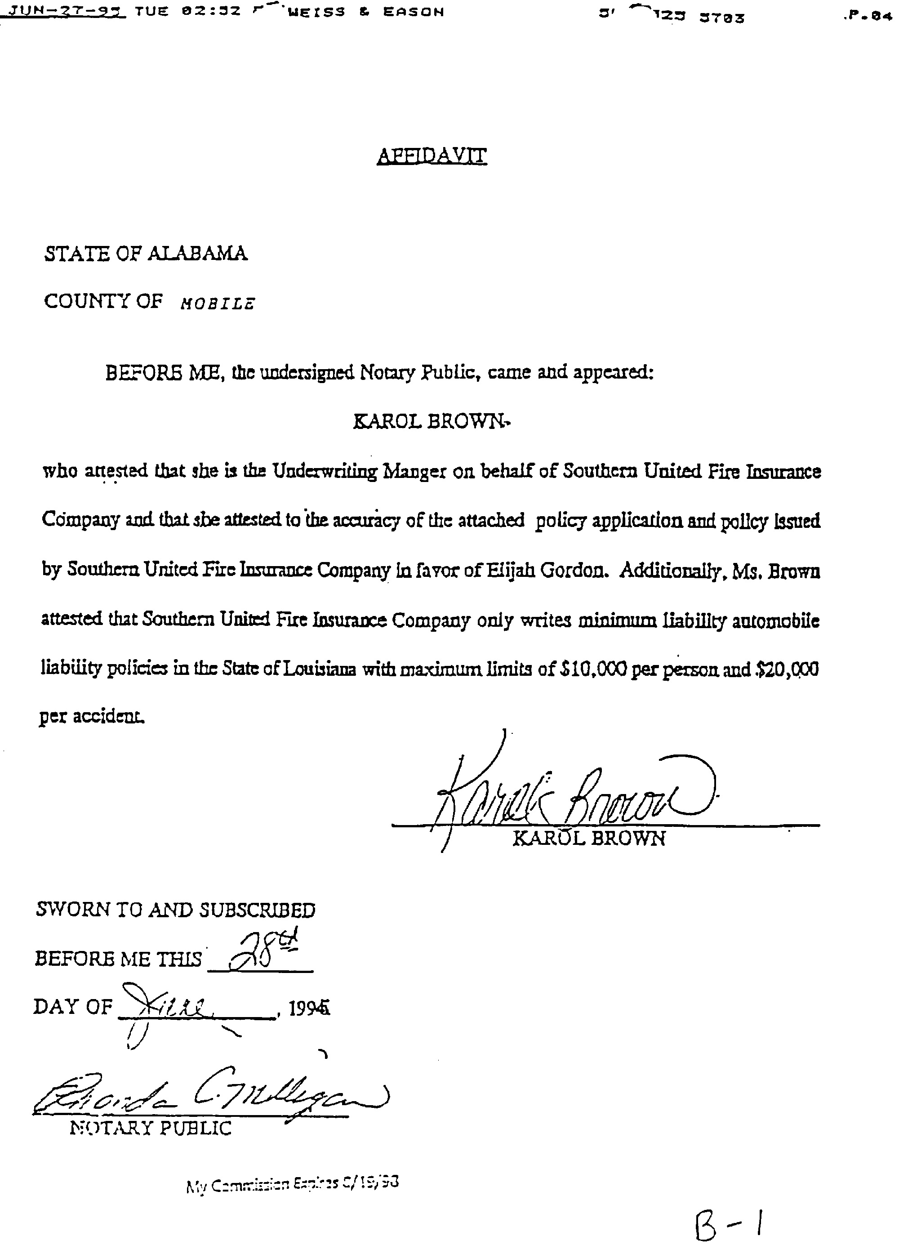

-----

Defendant presented the affidavit of Ms. Brown at the hearing on the motion for summary judgment, as support for its motion for summary judgment. Unfortunately for *593 defendants, the Karol Brown affidavit is most notable by its omissions.

Initially, I note that affidavits must be made upon personal knowledge and Ms. Brown, located in Alabama, has no personal knowledge of Mr. Gordon and whatever verbal representations were made to him. The defendant should have provided the affidavit of the agent at the Robert Sheard Insurance Agency who signed Mr. Gordon's application.

Turning to the Brown affidavit that was provided, in stating that “Southern United Fire Insurance Company only writes minimum liability automobile liability policies in the State of Louisiana with maximum limits of $10,000 per person and $20,000 per accident”, does she mean that “Southern only writes 10/20/10 minimum liability automobile liability policies which include UM coverage unless rejected, but does not write policies for higher monetary amounts”or does she mean that “Southern only writes 10/20/10 minimum liability automobile liability policies”, meaning that Southern only writes bodily injury and property damage liability policies and does not write UM, Med Pay, Comprehensive, Collision, Towing, etc. Is she saying that Southern does not write UM coverage? Under Dibos, supra, defendant failed to carry its strict standard by showing that it is quite clear as to what the truth is and that excludes any real doubt as to the existence of material fact. Additionally, under Vermilion, Carr, and Duvalle, all supra, we are bound to construe the affidavit most favorable to the non-moving party, hence we are bound to construe the affidavit against Southern, thus Southern did not carry its burden of proof for a summary judgment and the trial judge correctly denied the motion.

III. SOUTHERN MARKET STRATEGY

The majority opinion assumes“Southern would certainly have been only too glad to collect more premium dollars by selling plaintiff the UM coverage.” I do not agree with that assumption. I believe that the three critical elements in this case, namely a UM selection form which only states rejection, an ambiguous affidavit describing the type of insurance Southern provides and a largely empty policy declarations page, all indicate that Southern was selective in what it offered. The documentary evidence before us leads me to the conclusion that the form drafted by Southern only rejects UM coverage, because of Southern's attempt to define its place in the low-premium auto insurance marketplace.

Consider the following: First, the UM selection form only states rejection. Second, one interpretation of Karol Brown's affidavit is that it implies that Southern does not write UM coverage. Third is the Declarations Page of the Policy which indicates:

COVERAGES |  | AUTO NO 1 |  | AUTO NO 2 |  | TOTAL
 |  |  |  |  |  | PREMIUMS
 |  |  |  |  |  | Each Coverage
A. | Bodily Injury Liability |  | $ INCL |  | $ INCL |  | A.
B. | Property Damage |  | $ 374 |  | $ 286 |  | B. |  | $ 650
 | Liability
C. | Automobile Medical |  | $ |  | $ |  | C.
 | Payments
D. | Uninsured Motorists |  | $ |  | $ |  | D.
E. | Comprehensive |  | $ |  | $ |  | E.
F. | Collision |  | $ |  | $ |  | F.
G. | Fire, Theft, & |  | $ |  | $ |  | G.
 | Combined Additional
H. | Personal Effects |  | $ |  | $ |  | H.
I. | Towing |  | $ |  | $ |  | I.
 |  |  |  |  | TOTAL |  |  |  | $ 650
 |  |  |  |  | PREMIUM
 |  |  |  |  | Policy Fee |  |  |  | $ 45
 |  |  |  |  | MVR |  |  |  | $ 5
 |  |  |  |  | TOTAL |  |  |  | $ 700

*594 This declarations page is consistent with an interpretation that Southern does not provide anything other than 10/20/10 bodily injury liability and property damage liability auto policies. Under this interpretation of the documents before us, the basis of the trial court's denial of the summary judgment is that even though Southern takes the market position that it simply does not issue UM coverage, that market position is in violation of Louisiana law which by operation of law imposes the UM coverage, whether or not Southern chooses to issue it.

Southern may be taking its position in the marketplace as “the provider of 10/20/10 insurance, only to people who reject UM coverage”. The “reject-only” market strategy would enable Southern to offer lower premiums in an already low-end market. Southern would then take the position vis-a-vis its customers, “Louisiana law requires that UM coverage be issued with every policy delivered or issued in Louisiana, unless rejected by the insured, but Southern chooses to sell insurance only to insureds who choose to reject UM coverage. If you choose to reject UM coverage, we will sell you a policy. If you do not choose to reject UM coverage (or if you want UM coverage), you can still buy insurance, but you have to buy it from someone other than Southern. Because Southern doesn't issue UM coverage, we only have one option, rejection, on our form, and because upon signing we have the insured's written rejection, we are not required to issue UM coverage under the statute.” Would Southern's market position be violative of the strong public policy favoring UM coverage in Louisiana law? Perhaps the trial court denied summary judgment because it believed that Southern's market position as “the provider of 10/20/10 insurance, only to people who reject UM coverage” is violative of Louisiana law.

This court has neither transcript nor written reasons for judgment in the application before us, but it is a valid inference on the record before us that the trial court judge denied the motion for summary judgment because he found Southern's refusal to provide UM insurance in conflict with and violative of Louisiana law because it not only fails to provide a meaningful choice under Tugwell, supra, but fails to provide any choice at all.

Another alternative consistent with a form only with a rejection option, Karol Brown's affidavit and the fact that the declarations page shows no insurance other than 10/20/10 bodily injury and physical damage, centers on the issue of financing. Mr. Gordon financed $601.00 of the $700.00 total. Because we do not know the lending standards applied or the state of Mr. Gordon's finances, we do not know if he could have qualified for financing if an additional amount for a UM premium had been added to the $700.00 total. Perhaps Southern took the position, if you don't get UM, we'll finance the premium, if you get UM, we won't finance the premium. Once again, these questions go to Mr. Gordon's ability to make a meaningful rejection and his knowledge at the time of the rejection, both genuine issues of material fact such that summary judgment was correctly denied.

IV. PREMIUM PAYMENT

The majority makes the argument that a premium was not paid for the UM Coverage. Holbrook, supra, further finds “the customer possesses UM Coverage as a matter of law. In other words, the policy holder does not have to do an affirmative act”. Payment of an additional premium is an affirmative act. Where there is no written rejection of UM coverage, UM coverage is provided whether or not a separate UM premium is paid, because the only legislative exception is the written rejection of UM coverage, not the lack of premium payment.

Premium regulation lies within the unique jurisdiction of the Insurance Commissioner. Insurance rates are regulated by the State through the Commissioner. We do not know if the argument “insurers are required to provide UM coverage in every policy issued” has been used to increase the overall insurance rates by including a percentage for UM Coverage in the state authorized rates. We need to explore the rate formula and the history of its increases in order to determine *595 if policyholders are already paying for UM coverage in their base rates. No such evidence was presented in the record before us. I note that perhaps a better solution to the thousands of dollars wasted in litigation over the validity of rejection forms would be to simply include a premium for UM coverage in every rate structure and ordain that thus every insured in Louisiana has UM coverage.

V. SUMMARY JUDGMENT & CONCLUSION

In Holbrook, supra, at page 809, the court further stated “Given the oft-stated favorable public policy and jurisprudentially expressed liberal rules governing UM coverage, it seems that it would be a simple task to draft UM selection/rejection forms to state clearly, unambiguously and unmistakably the options mandated by L.A.R.S. 22:1406(D)(1)(a)(i-ii) and Tugwell, supra...” The court concluded “if certain insurance companies continue to write vague and ambiguous policies, and disregard the requirements of the waiver of U.M. coverage, as clearly enunciated in the statutes and court opinions, they have no one to blame but themselves for unfavorable judgments and opinions regarding interpretation of U.M. policy provisions.”

For the reasons discussed, upon my independent de novo review of the writ application before us, I find, as did the trial court, that the motion for summary judgment was properly denied.

MURRAY, Judge, dissenting:
I respectfully dissent. For over thirty years, Louisiana law has expressly required that UM coverage be included in every automobile liability policy issued in the state unless rejected by the insured. See 1962 La.Acts 187, effective October 1, 1962; Pierce v. Hartford Accident & Indemnity Co., 184 So.2d 241, 244 (La.App. 1st Cir.), writ refused,249 La. 201, 186 So.2d 160 (1966). It has long been recognized that this requirement reflects the strong public interest in protecting innocent accident victims injured by a tortfeasor who carried inadequate liability insurance. Booth v. Fireman's Fund Ins. Co., 253 La. 521, 527, 218 So.2d 580, 583 (1968). Because this public policy favors full recovery for the injured over normal contractual principles, any exception to the mandatory UM coverage is to be strictly construed in favor of finding coverage. Roger v. Estate of Moulton, 513 So.2d 1126, 1130 (La.1987). Accordingly, in order to escape the statutory obligation to provide this coverage, an insurer bears the burden of proving a valid rejection. Id. In order to meet this burden, “the insurer must place the insured in a position to make an informed rejection of UM coverage.” (emphasis added) Henson v. Safeco Ins. Cos., 585 So.2d 534, 539 (La.1991).

In this case, Mr. Gordon signed below the statement that “I HAVE BEEN OFFERED and I hereby REJECT” UM coverage. While I agree with the majority's conclusion that this appears unambiguous, such apparently unambiguous rejections have not been sufficient to establish a valid waiver of UM coverage when the insurer has not proven that the insured was informed of all options available under the law. See, e.g., Roger, 513 So.2d at 1131 (“[The] expression of a desire not to have UM coverage, however clear, does not necessarily constitute a valid rejection,” quoting Jordan v. Honea, 407 So.2d 503 (La.App. 1st Cir.1981), writ denied,409 So.2d 654 [La.1982] ); Tugwell v. State Farm Ins. Co., 609 So.2d 195, 197 (La.1992) (“The insured in this case appears to have expressly rejected UM coverage,” but rejection held invalid); Aramburo v. Travelers Ins. Co., 426 So.2d 260 (La.App. 4th Cir.), writ denied,433 So.2d 161 (La.1983); Uhrich v. Nat'l Fire Ins. Co., 569 So.2d 1062 (La.App. 3d Cir.1990), writ denied,572 So.2d 96-97 (La.1991).

In Bertrand v. Shelter General Ins. Co., 571 So.2d 861, 865-66 (La.App. 3d Cir.1990), the plaintiffs argued “that the rejection of UM coverage ... was ineffective because Mr. Bertrand was never informed of his option to select UM coverage in limits less than the bodily injury limits.” The Third Circuit rejected the argument, stating that “[w]e can find nothing in the statute or jurisprudence which would require that for a rejection of UM coverage to be valid, an insured must be informed of his option to select lower limits.” However, this language was quoted and expressly disapproved by the Supreme Court in Tugwell, 609 So.2d at 199:

*596 Implicit in the statute's requirement that the insurer make available to the insured the option of selecting lower limits is the idea that the insured be made aware of that option. [The] requirement that the insured be given the option of selecting lower limits would be empty protection indeed if the insurer were not also required to make sure the insured is informed of such an option. An insured cannot exercise an option he does not know exists.

The Court was equally clear in requiring that “the form used by the insurance company must give the applicant the opportunity to make a ‘meaningful selection’ from his options provided by the statute.” Tugwell at 197. Thus, the Supreme Court has established that, in order to find a valid rejection, a reviewing court must determine that the form itself shows the applicant was informed of his options and that he then made the selection from among the available options. Unlike Mr. Gordon, the insured in Tugwell had the option of selecting UM limits lower than his liability limits.^{FN1} Nonetheless, this principle must be applied to determine the validity of a rejection under any circumstances, not simply those occasions when lower limits are available. Tugwell at 199 n. 6.

FN1. Because this was a minimum liability policy there was no need for Mr. Gordon to be advised of his option to select UM coverage lower than his liability limits. Morgan v. Sanchez, 94-0090 (La.App. 1st Cir. 4/15/94), 635 So.2d 786.

In this case Mr. Gordon had two options: he could accept UM coverage or he could reject UM coverage. The waiver he signed, after advising that Louisiana law required that all automobile policies issued or delivered in Louisiana afforded UM coverage unless it was rejected by the insured, gave him one option: to reject UM coverage. There was no place for him to accept UM coverage.^{FN2} Were the majority correct in its characterization of La.Rev.Stat.Ann. § 22:1406D(1)(a) as an “R.S.V.P. regrets only” statute, this could be a valid waiver. However, that interpretation ignores the strong policy underlying the statute, which the jurisprudence has found to require that “regrets” to the invitation to coverage be meaningful.

FN2. The waiver executed by Mr. Gordon is contained in the majority opinion at p. 583.

In addition to giving Mr. Gordon only one option, the application in this case apparently was completed before it was presented to Mr. Gordon to sign. The portion of the application indicating that UM coverage was “Not Incld,” was computer generated, and a handwritten and circled “X” preceded Mr. Gordon's signature. Two equally plausible inferences may be drawn from this application: the agent fully informed Mr. Gordon of the purpose of UM coverage and the options available to him under the law before preparing the form; or the agent, at best, glossed over this information and told Mr. Gordon to “sign here and here” to obtain the minimum liability coverage required by law.

In my view, when there are two reasonable inferences to be drawn from the evidence presented, each as likely as the other, the insurer has not carried its burden of proving an informed rejection under the law. Thus, this form does not establish, unambiguously, that Mr. Gordon was given the opportunity to make a “meaningful selection” between acceptance and rejection of UM coverage. Rather, like the application seen in Henson, 585 So.2d at 539, the application form signed by Mr. Gordon suggests strongly that “the insurer ... attempted to set up an automatic rejection of UM coverage.”

I acknowledge that Tugwell, 609 So.2d at 199, suggests approval of a rejection form in which the insurer “require[s] the insured to acknowledge in writing he has been informed of the options.” However, given the strong public policy expressed in the UM statute and repeatedly emphasized by our courts, I cannot read Tugwell as sanctioning the form Mr. Gordon signed. Instead, the explicit requirements otherwise set forth in that opinion suggest to me that the Court intended that an applicant be informed of his options and acknowledge that information before he makes his “meaningful selection.” As noted above, because the application form was completed before being presented to Mr. Gordon to execute the rejection, I find that it *597 does not establish that he made a meaningful selection from his available options.

The Supreme Court's opinion in Tugwell, setting forth the principles to guide our interpretation of La.Rev.Stat.Ann. § 22:1406D(1)(a), was rendered in 1992. There has been no subsequent legislative action to overrule or modify the Tugwell precepts. Absent a legislative retreat from the strong public policy reflected in our Supreme Court's interpretation of the statute, this court should not erode that policy by assuming an informed and meaningful UM rejection from a form that does not unambiguously establish that such was the case.

I take exception to the majority's partial reliance on the fact that the insured in this case did not pay for UM coverage, characterizing an alleged “windfall” from the coverage implied by law as “bad public policy.” This pronouncement directly contradicts the Supreme Court's consistent emphasis that “[t]he law imposes UM coverage in this state notwithstanding the language of the policy, the intentions of the parties, or the presence or absence of a premium charge or payment.” Roger, 513 So.2d at 1131-32 (citing Alexander v. Allstate Ins. Co., 493 So.2d 677 [La.App.2d Cir.1986] ).

Additionally, the majority has determined that “Southern would certainly have been only too glad to collect more premium dollars by selling plaintiff the UM coverage.” This may be true. However, it may also be true that insurers, such as Southern, currently selling policies in this state are not eager to reduce their ability to compete in an insurance market where price may be more important than the extent of coverage. Furthermore, if the publicity surrounding our new governor's first legislative session is to be believed, the great number of un- and under-insured motorists on our highways well could dampen other insurers' enthusiasm for incurring the risks of providing UM coverage.

For these reasons, I respectfully dissent from the majority's opinion in this case. I do not find that the form executed by Mr. Gordon is sufficient to establish a valid rejection under La.Rev.Stat.Ann. § 22:1406D(1)(a), as that statute has been interpreted by our Supreme Court.

La.App. 4 Cir.,1996.
Gordon v. Southern United Fire Ins. Co.
679 So.2d 582, 95-2388 (La.App. 4 Cir. 8/21/96)

END OF DOCUMENT

